Romeo and Juliet Projects 2014
Instructions
- Form a group of 4. Choose one project from the options provided. You are required to create your project, present it and prepare revision notes. These could include and are not limited to:
  - a summary sheet of the scene chosen
  - 5 possible well-crafted exam questions
  - An adequate list of relevant quotes, their explanation and significance.
- Try to create an authentic and spectacular experience for your audience. This will require you to research on the types of clothes worn at the time of the play and the setting used to stage the play.
- You will be required to submit all artefacts for grading, including evidence of research.
- Print for the entire class the revision notes that you have prepared. Include your group members’ names on all work submitted.
- You will be graded on how extensive your research has been, effort put into your work, quality of your artifacts / products as well as your revision notes, adherence to deadline and creativity.
Deadline: First lesson of week 5, Term 2.
Rubric
 | 1 | 2 | 3 | Comments | Score
Completion | Appears as if parts are missing, looks incomplete. Unprepared to present in class. | Very few parts are missing, some research or items belonging to the project may have been left out. | Looks very well put together, and very ready to present to the class. Appears as if no piece(s) of information or characters have been left out.
Research | Appears to have minimal research done to create the project, looks random, not really mimicking the actual scene. | Appears that a considerable amount of research was done to create the project, shows the creator knows somewhat what they are doing. | Shows an excelling amount of research was done to complete the project, shows that the creator definitely knows the scene, and the characters well.
Creativity | Unoriginal, something that could've been found online, small amounts of creator's work. | Shows that some thought was put into the project, shows that the creator did take time to create an original piece of work. | Shows that the creator did thorough research to complete, and did not at all copy from an outside source. Looks well put together, and very creative.
Effort | Looks very unorganized, thrown together, information incorrect or missing, only read through that section, minimal research was done. | Looks presentable, appears to have used most of the time provided, somewhat studied that culture, read through the scene in the play. | Appears well made, looks ready to present, used the full amount of time provided for the project, studied actual scenes, read through the scene in the play.
Revision Notes | Somewhat useful but needed more thought. | Useful and organised. | Extensive, exceptionally useful and well-designed.
TOTAL
Option 1: Comic Book
Draw a comic book depicting a significant scene from the play. Your comic book should have pictures and captions and/or dialogues. The comic books should be creatively done and in colour. You will be graded on how well your project relates to the play, the creativity of your choices, and the overall presentation of your comic book. It may take the form of a manga or even be done using IT. Up to you!
Option 2: A Dramatic Performance
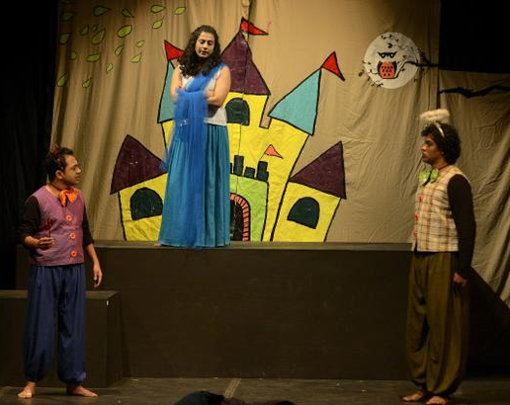  Here is an example:  http://www.youtube.com/watch?v=UQTOKMZqLok | Choose an important scene, memorise the lines and act it out with props. You will be graded on your skill in delivering the lines, your use of props, costumes, and the overall creativity of your performance. You could use puppets instead of real actors. For characters, you can make your own out of paper and toothpicks, clay, marshmallows, cardboard, or even make finger puppets, wooden marionettes, etc. Submit a video of your performance that is no longer than 5 minutes, including subtitles, credits and bloopers (if any).

Option 3: Newsflash
Create a newspaper with at least 4 pages covering your chosen scene from different perspective. The reports could include obituaries, advertisements, word puzzles, crime reports, etc. You could even choose to film it and present your news as a televised news report, like The Noose, perhaps?
Option 4: Game On
Create an original board game. It could be a deck of cards or an innovation of snakes and ladder, etc. Do not forget to come up with an instruction sheet including the rules and how to play and win the game.

Option 5: Children’s Book
Create a children’s book, outlining the details of the plot. You may cut some of the text, but the comic book should cover the entire play and Shakespeare's language should basically remain intact. Challenge yourself to include some pop out art!
Option 6: Diorama
Create a diorama of your favourite scene. Just be authentic and creative, paying special attention to detail and conducting research to be as authentic as possible. Include a 500 word explanation of the importance of the scene chosen to the rest of the play.  For example:  https://sites.google.com/site/thisenglishart/romeoandjulietdioramasy8 | 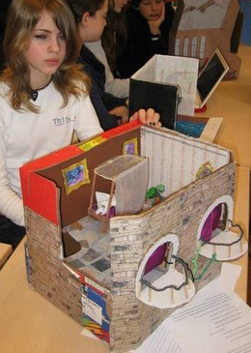
Option 7: Facebook Profiles
Create a detailed and authentic facebook page for 5 characters of your choice, showing their relationship and interaction with one another. You will present your profile on a poster (such as butcher paper for example). It should have a profile picture, other photos that have been posted by the character, status updates, personal information, friends, wall posts, and anything else that a typical Facebook wall profile would have.
Option 8: Animation
Create an animation of a scene of choice or outline the details of the plot.
For example: http://www.youtube.com/watch?v=pKpAw-pz5ac
Option 9: Artefact Collection
Create an artefact collection. Collect 10 items that you feel are essential to the plot, main characters, conflict, symbols, or themes of the play. You need to arrange your collection in a box or container of some kind and write an explanatory paragraph of the importance of each item. You could include letters or diary entries written in original Shakespearean English. Pay attention to font, paper choice and handwriting. Make the artifacts look as authentic as possible. You will be graded on how well your project relates to the play, the creativity of your choices, and your explanations for your choices.
Option 10: Travel Guide
Design a travel guide for tourists going to 16th Century England / Verona. The tourists reading this tour guide will then be able to broaden their knowledge about the history, places and culture in the respective places. The travel guide will provide insights on the uniqueness of 16th Century England / Verona, hence tourists will be interested to visit the place and its attractions.
Your travel guide should include the following components:
· A brief historical background of 16th Century England / Verona
· Geographical location, weather, seasons, climate, etc
· Places of interest
· Food
· Festivals
· Customs and beliefs

There can be six sections in you travel guide. The description for each component above should be written in prose form. You may wish to include images if you want to.
Option 11: Your Own Creation
If none of the choices listed appeal to you, try to come up with a creative project of your own. Some options include dances, songs, creating a soundtrack, creating an alternative ending or even baking cakes! Just check with me first! The sky is really the limit!

